
CMR INSTITUTE OF TECHNOLOGY
ACADEMIC YEAR 2025-2026(EVENSEM)
Flipped Classroom REPORT
Department of Information Science and Engineering

Subject code | BIS601 | Course Name | Full Stack Development
Semester / Section | VI- B | Prepared By | Ms. Jayashree M
Curriculum Gap Identified: | NA

Summary of Flipped Classes conducted:
Sl No. | Topic | Date | Flipped class / Video Session (Choose from drop down) | Total number of students
1 | Basic HTML Tags and Form Elements | 10/2/26 | Flipping the Teacher | 45
2 | JavaScript -Event handling | 24/02/26 | Flipping the Teacher | 45
3 | React Classes | 02/04/26 | Flipping the Teacher | 40

Detailed Report
1 | Basic HTML Tags and Form Elements | Date : 10/2/26 | Flipping the Teacher | No. of students: 45
Materials Shared Before Class

Full Stack Development material was shared with students through Google Class Room. The proof link of study Materials is shared in advance and the link is given below.
https://classroom.google.com/c/ODQyMzk5MDM3MTg4
Conduction of Flipped Classroom
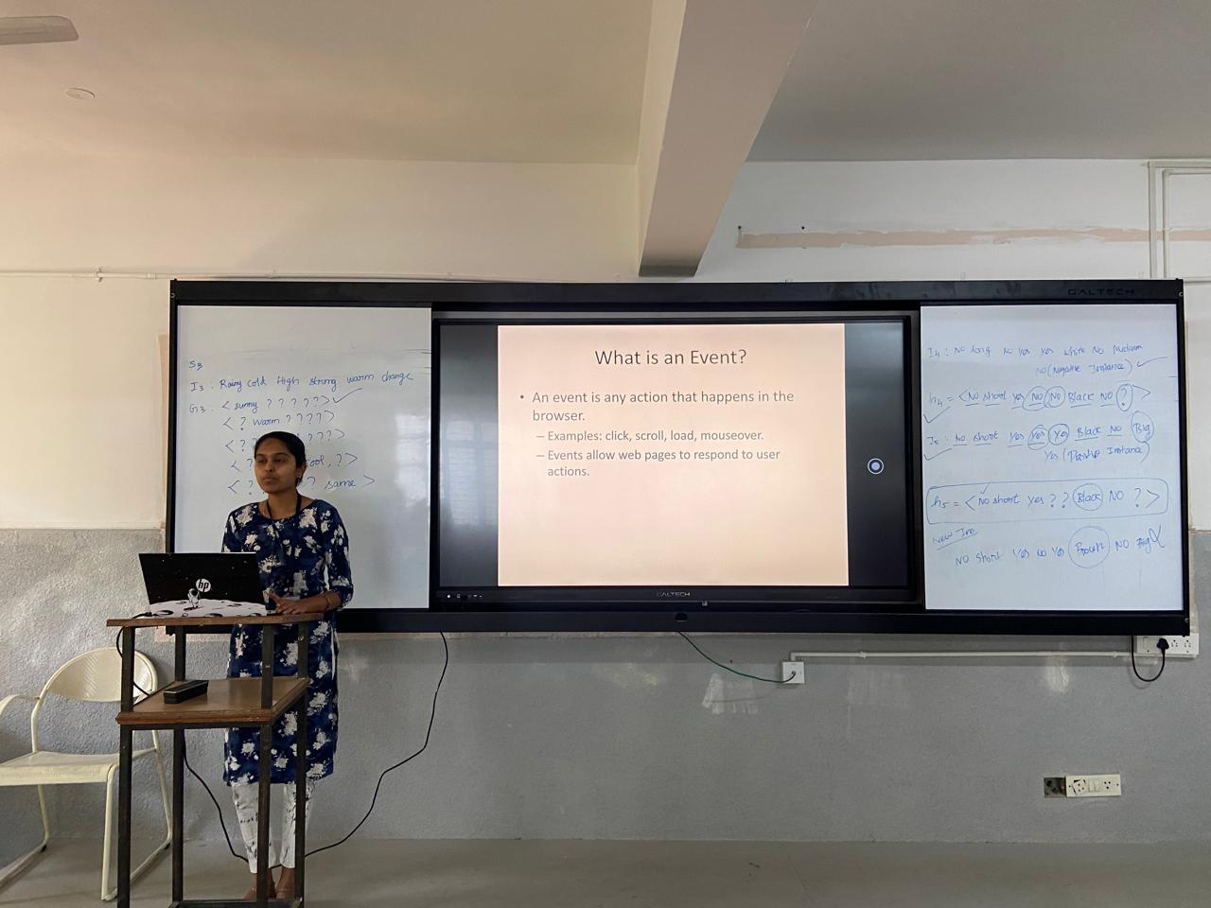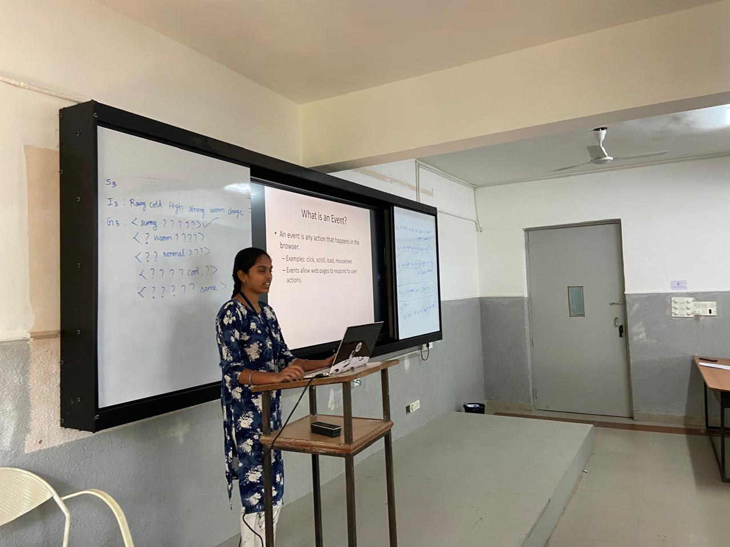
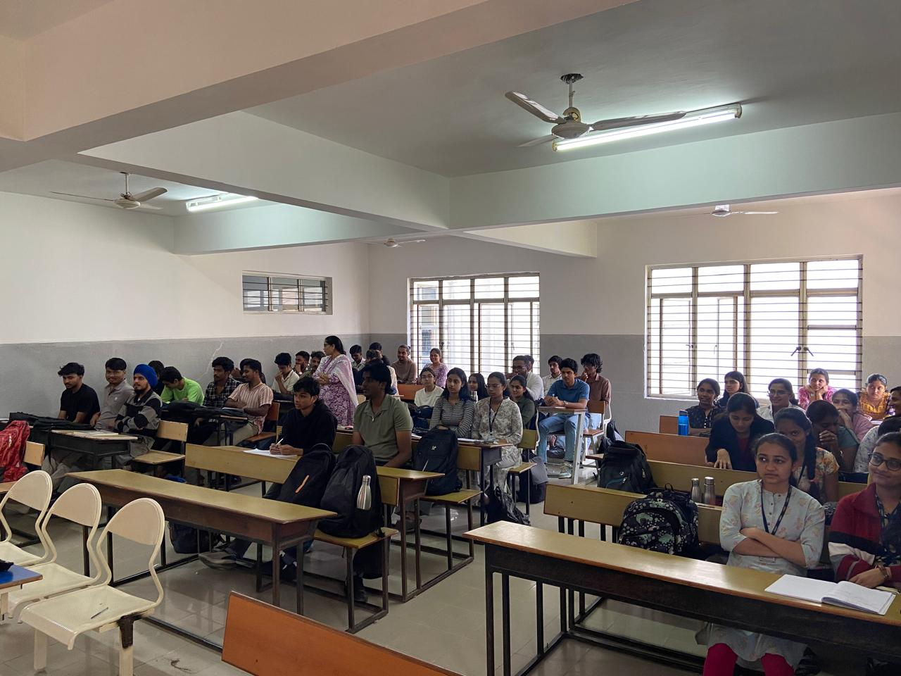

The student by name Lahari explained the concept of HTML Form Elements and demonstrated the events like Mouse mouse events, and also demonstrated the program and run in the visual studio.
Evaluation :
Outcome:
The outcome of this flipped classroom is:
The environment of the Visual studio and use of terminal and to run the program in the browser.
To push students to higher order blooms levels such as L2 and L3.
The PO’s and PSO’s that are addressed by doing this flip class are as follows:
PO’s- 1,2,3,4,6,12
PSO’s- 1,2,3,4

2 | JavaScript -Event handling | Date : 24/02/26 | Flipping the Teacher | No. of students: 45
Materials Shared Before Class

Full Stack Development material was shared with students through Google Class Room. The proof link of study Materials is shared in advance and the link is given below.
https://classroom.google.com/c/ODQyMzk5MDM3MTg4
Conduction of Flipped Classroom
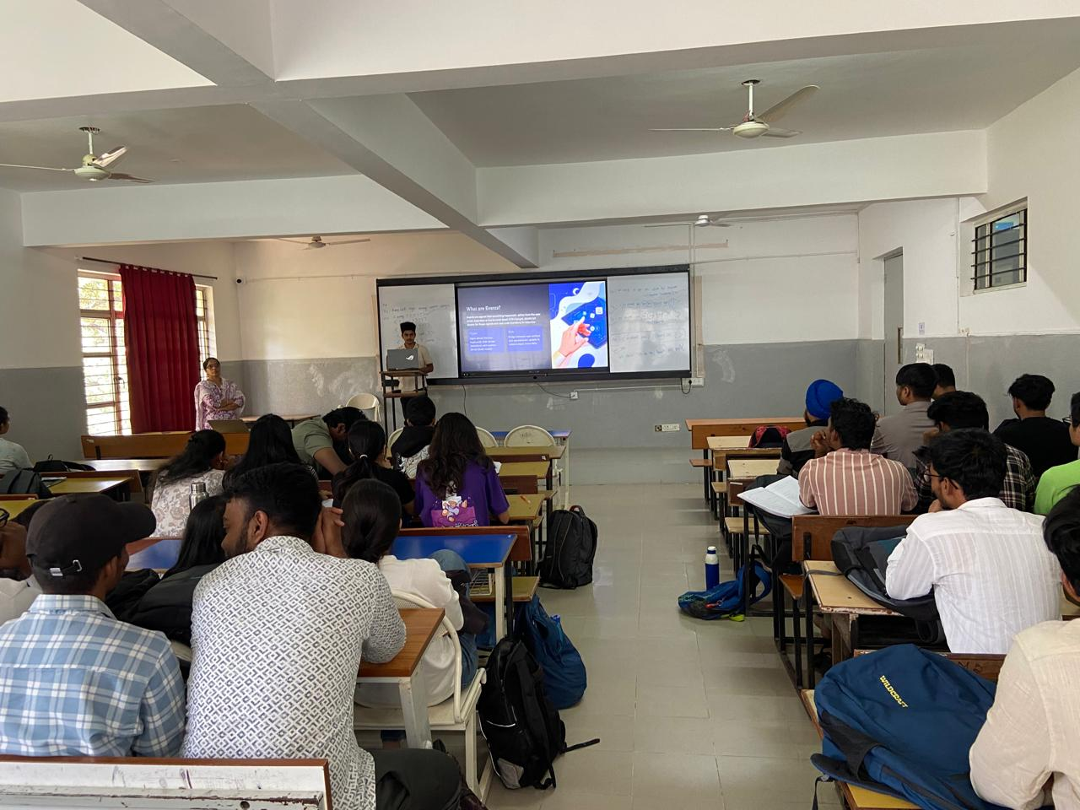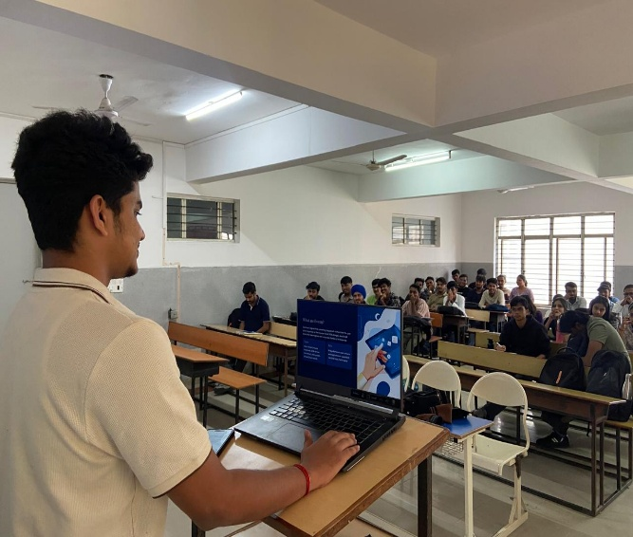
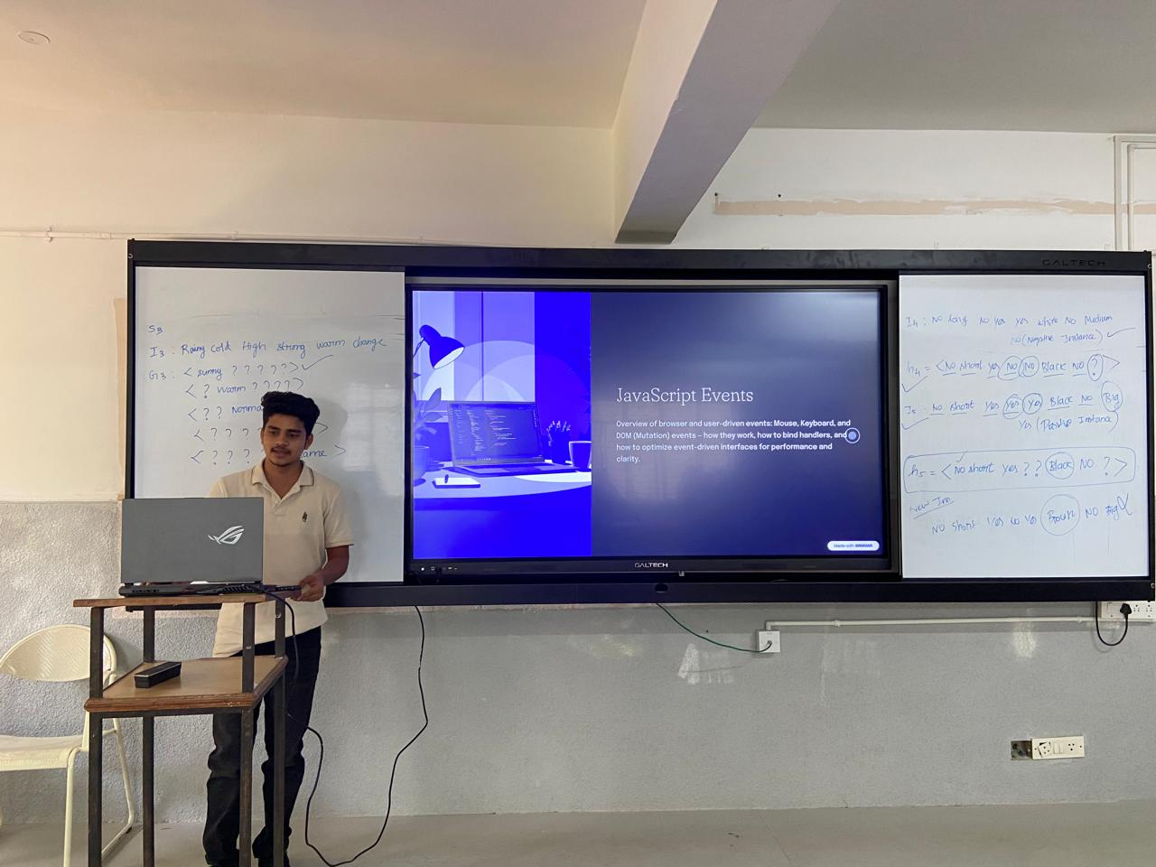

The student by name Samarth (1CR23IS073)explained the JAVA script Elements and event Listeners concept .Demonstrated with execution in the visual studio environment
Evaluation :
Tested the students by asking the questions related to the explained concept and they were able to differentiate the different event listener concept
Outcome:
The outcome of this flipped classroom is:
The environment of the Visual studio
To push students to higher order blooms levels such as L2 and L3.
The PO’s and PSO’s that are addressed by doing this flip class are as follows:
PO’s- 1,2,3,4,6,12
PSO’s- 1,2,3,4
3 | React classes | Date: 02-04-2026 | Flipping the Teacher | No. of students:40
Materials Shared Before Class
Full Stack Development material was shared with students through Google Class Room. The proof link of study Materials is shared in advance and the link is given below.
https://classroom.google.com/c/ODQyMzk5MDM3MTg4
Conduction of Flipped Classroom
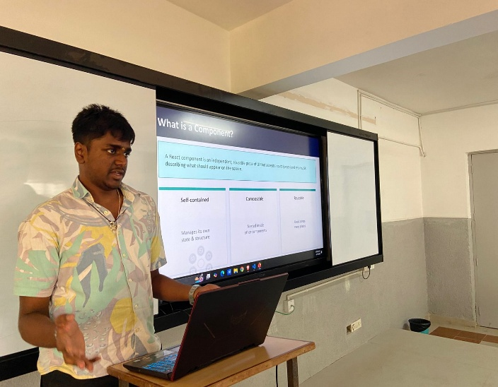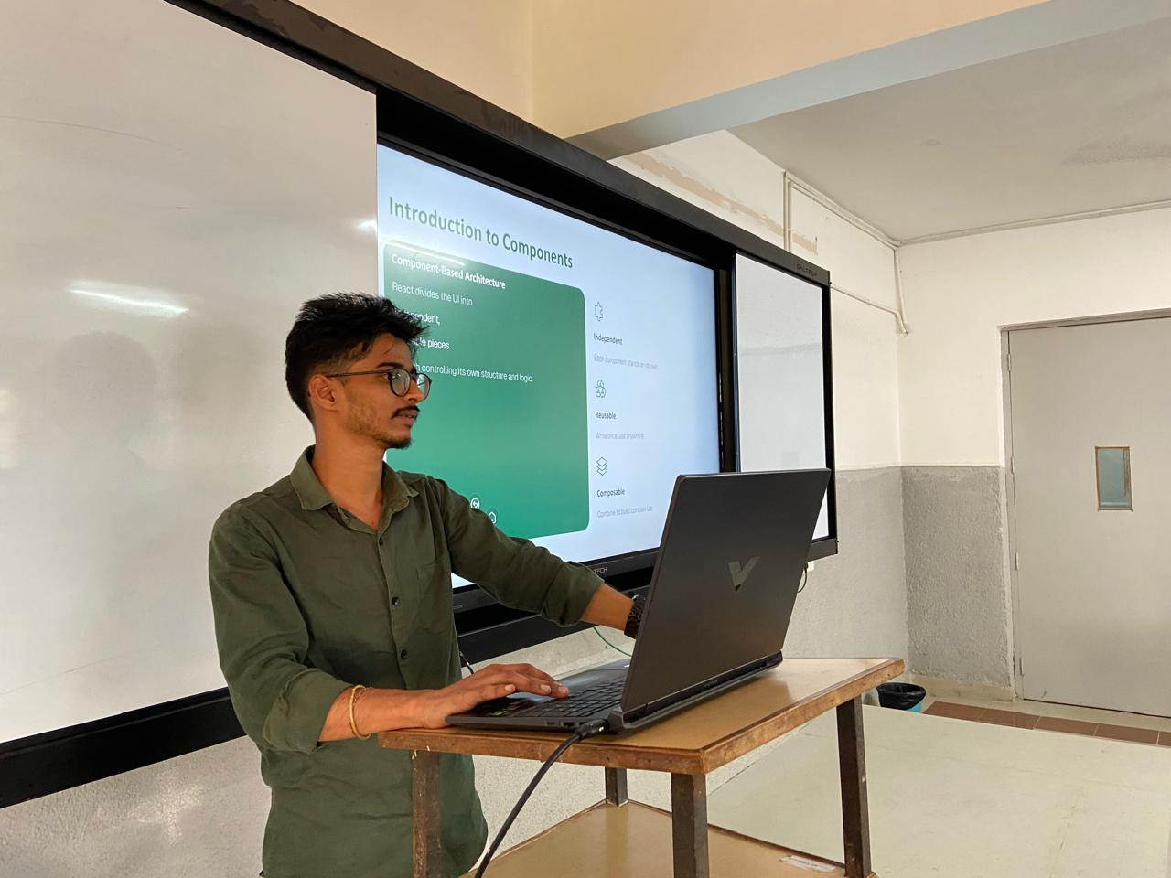
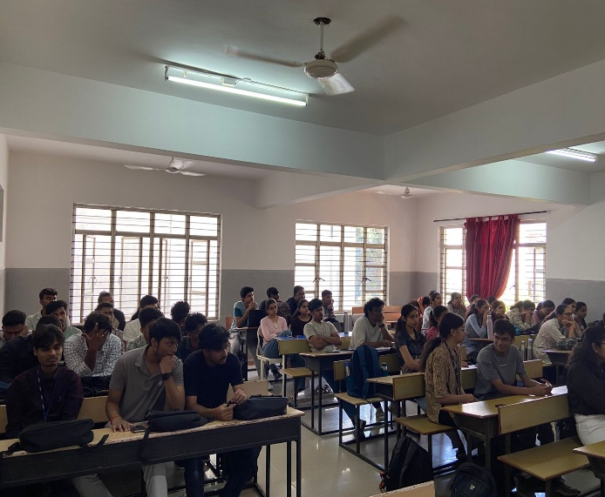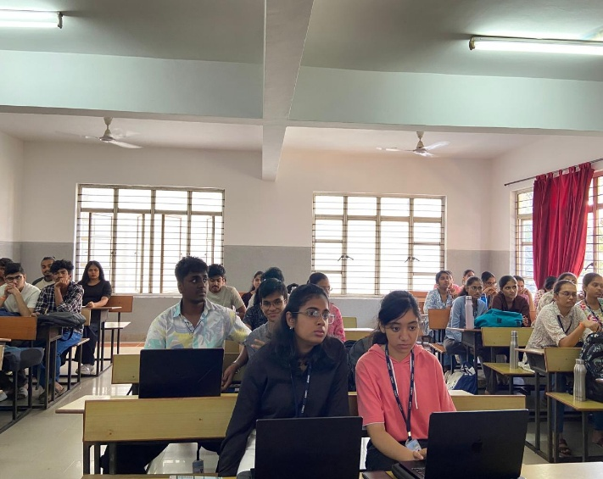
The student byname Akash and lakshmeesha Explained about Designing the components in React and component hierarchy in react, they demonstrated with example by running the program in the vscode. students were able to understand the concepts .

Evaluation :
Outcome:
The outcome of this flipped classroom is:
The environment of the vscode for running the program of react.
To push students to higher order blooms levels such as L2 and L3.
The PO’s and PSO’s that are addressed by doing this flip class are as follows:
PO’s- 1,2,3,4,6,12
PSO’s- 1,2,3,4

